**Implementing Automatic Attendance Marker Using FaceRecognition**

Author

*1,2,3Student, 4 Professor, Kiet Group of Institutions, Ghaziabad, Uttar Pradesh.*

*Corresponding Author:Shaurya Awasthi, Sparsh Verma, Tushar Sharma, Amit Sanger*

**ABSTRACT**: Face is the crucial part of the human body that uniquely identifies a person. Using the face characteristics as biometric, the face recognition system can be implemented. The most demanding task in any organisation is attendance marking. In the traditional attendance system, the students are called out by the teachers and their presence or absence is marked accordingly. In this project, the Open CV based face recognition approach has been proposed. This model integrates a camera that captures an input image, an algorithm for detecting faces from an input image, encoding and identifying the face, and marking the attendance in a spreadsheet. The training database is created by training the system with the faces of the authorised students. The cropped images are then stored as a database with respective labels. The superiority of our model is demonstrated by the obtained accuracy, which exceeds 91% at a rate of about 4-5 frames per second. We've also shown how to recognise faces in real life using our technique with just a few training images, and the results are quite encouraging.

**KEYWORDS:** Face recognition, OpenCV, KNN algorithm, automatic attendance , Haar-Cascade Classifier , authentication , attendance system ..

1. **INTRODUCTION**

Attendance tracking is a fundamental aspect of educational institutions, serving as a critical tool for monitoring and ensuring students' academic progress. While the methods for tracking attendance vary across institutions, they generally fall into two categories: traditional paper-based systems and modern, automated approaches, such as biometric solutions. Among the innovative technological advancements in attendance management, facial recognition systems have emerged as a powerful tool. This paper explores the utility of facial recognition technology as an inventive way to enhance attendance management, comparing it with other biometric methods and discussing its applications in educational institutions. Academic establishments have a stake in keeping an eye on student attendance. A student's academic achievement is frequently closely linked to their attendance patterns. Teachers that have consistent attendance are better able to assess student involvement, monitor policy compliance, and spot pupils who can benefit from extra help. In the past, paper records or files were used to manually track attendance; these records were prone to inaccuracies, manipulation, and inefficiencies. As technology has developed, organizations have looked for more dependable and effective ways to monitor attendance. Biometric systems are becoming more and more common in many fields, including education. Utilizing distinct physiological or behavioral traits to identify people is known as biometrics. Ocular biometrics, facial recognition, and fingerprint recognition are a few examples of biometric techniques.Biometric technologies are the best option for tracking attendance because they are very precise and challenging to tamper with attendance. One area of biometrics that has seen a lot of development and attention recently is facial recognition technology. It operates by comparing patterns in an individual's facial features to validate or identify that person. The key components of a facial recognition system include capturing an image of the face, analyzing key facial landmarks, and comparing these features with a database of known individuals. When a match is found, the system can mark the student as "present".

1. **LITERATURE OVERVIEW**

Over the past ten years i.e. from 2013 to 2023, there have been 25114 conferences, 4250 journals, and 211 magazines. The query, performed on IEEE Explorer on NOV 4, 2023. Figure1 shows a comparison of all the documents that Published.

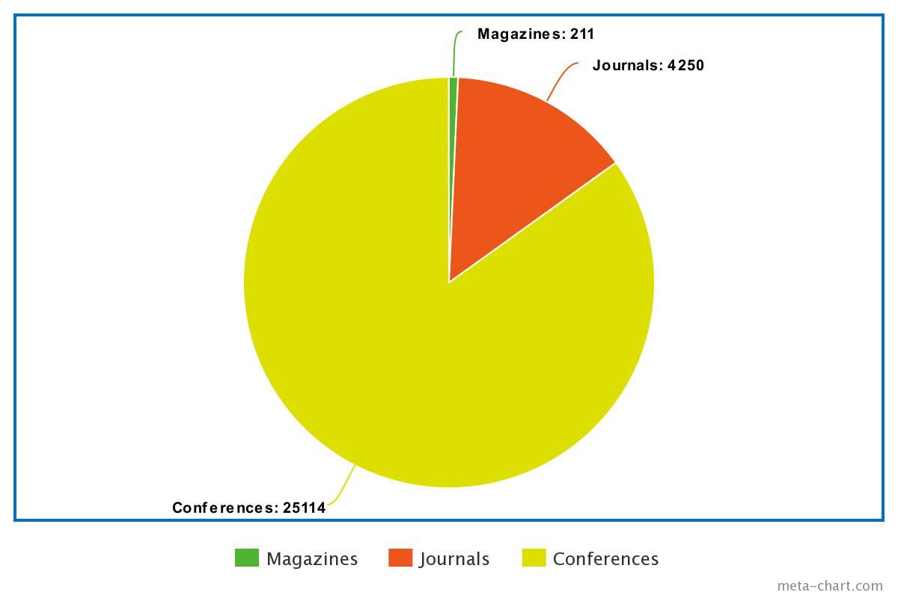

**Fig. 1. Published Article by Type [2013-2023]**

Figure 2 introduces the total number of publications published annually. It makes it evident that, between 2012 and 2022, there has been a huge increase in the number of documents. In addition to this, we can observe general growth.

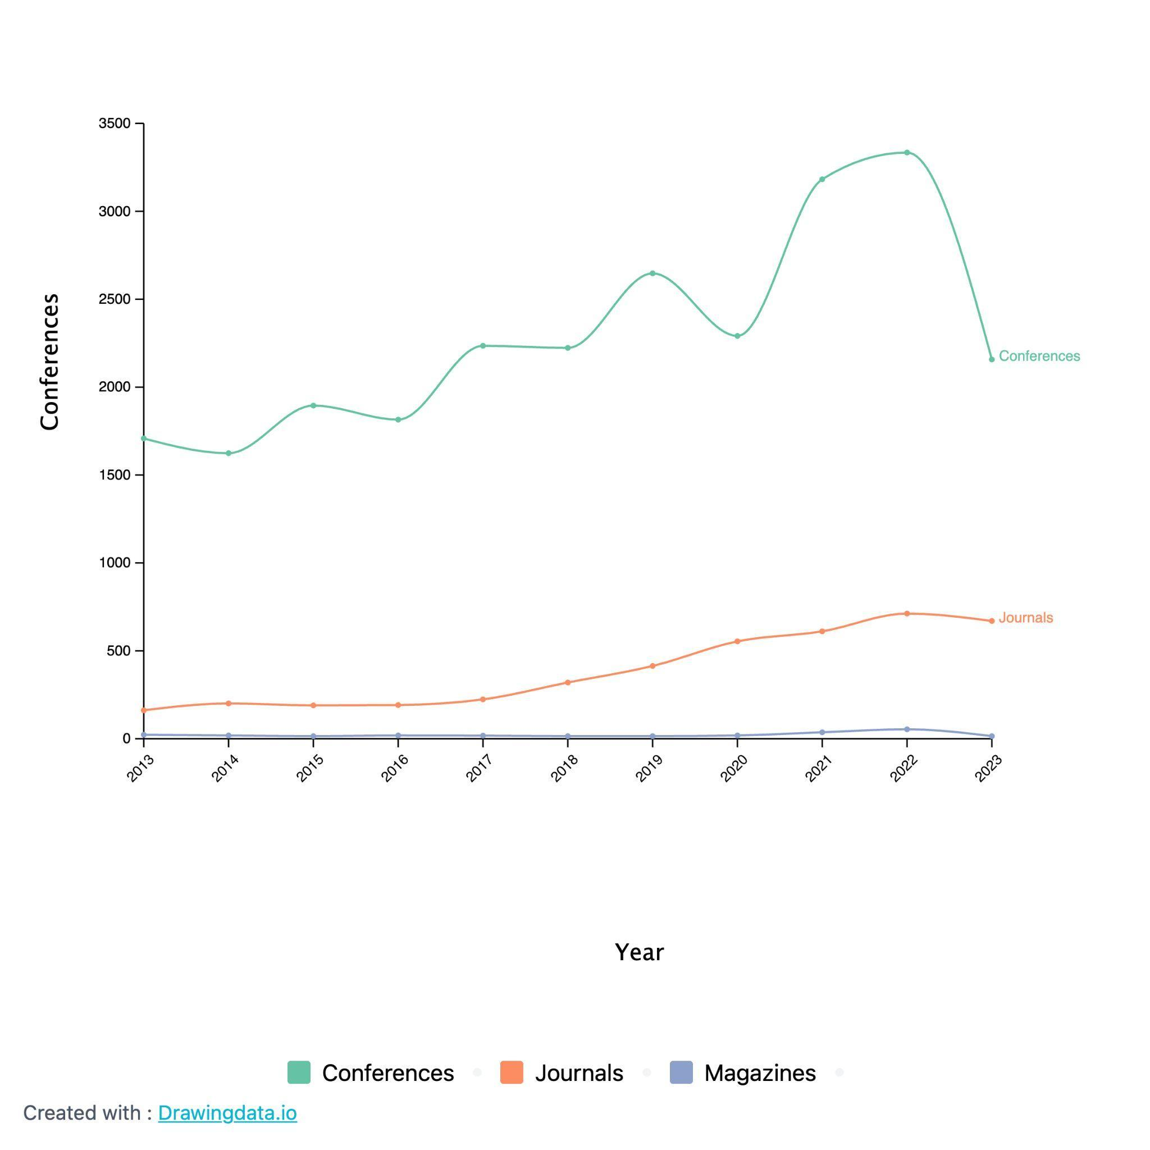

Table 1 provides a comprehensive summary of key research papers in the field of friction, showcasing a diverse range of models, techniques, and results employed by researchers in their investigations. The references included in this table span various years, reflecting the evolving nature of friction research.

**Fig. 2. Documents by Year [2013-2023]**

**Table 1. Major Contributions In Face Detection and Recognition**

| **References** | **Model used** | **Techniques** | **Year** | **Result** |
| --- | --- | --- | --- | --- |
| [5] | Convolutional Neural Network | feature detector | 2023 | The model Recognizes Face having Mask or Not. |
| [6] | DNN Caffe  SVM Classifier | Facial recognition | 2023 | This project contributes to attendance management practices, while offering potential solutions to overcome its limitations. |
| [7] | Haar Cascade  Convolutional Neural Network | Facial Emotion Recognition (FER) | 2023 | Recognise facial expression catering to the growing need for personalized and adaptive learning experiences |
| [8] | Deep Convolutional Neural Networks (DCNNs) | Face Detection and Identification.  Behavioral and Computational Evidence. | 2023 | The researchers in this project use DCNNs as computational models to understand and model biological face recognition |
| [9] | The project utilizes the "4D development model"-Define, Design, Develop, and Disseminate | The key technology being leveraged is Face Recognition.  Biometric Technology: | 2023 | The research resulted in the development of a "Biometric Face Recognition System for Digital Learning Authentication." |
| [14] | Haar Cascade  Convolutional Neural Network | Automated Attendance Systems (AASs)  Smart Cards  Biometric Technology | 2023 | The result highlights the benefits of using Automated Attendance Systems, such as saving time and space in classrooms when properly implemented |
| [16] | deep learning models for face recognition include VGGFace, FaceNet, and OpenFace | Face Recognition  Live Camera Feed  Back-End Server | 2022 | Marking Attendance in realtime in the database. |
| [19] | The model used in this project is a hybrid feature extraction method that combines “Convolutional Neural Network” (CNN) and “Principal Component Analysis” (PCA) | Convolutional Neural Network (CNN)  Principal Component Analysis (PCA)  Real-time processing | 2019 | the system has very accurate data processing and high accuracy, making it reliable and powerful for identifying human faces in real-time. |
| [21] | Face recognition can be implemented using various deep learning models, such as (CNNs) or pre-trained models like VGG, ResNet, or custom architectures | This is the primary technology used for automatic attendance management | 2018 | To improve the convenience and data reliability of attendance management using face recognition technology |

1. **METHODOLOGY**

The proposed system for class attendance management involves students registering by providing their required information and having their pictures taken, which are then stored in a dataset. During the class sessions, the system will capture the student’s faces in the classroom to detect and recognise further. These detected faces will be compared with the images in the dataset. When a match is identified, the system will record the student's attendance

At the conclusion of each class session, a list of students who are present will be generated date-wise.

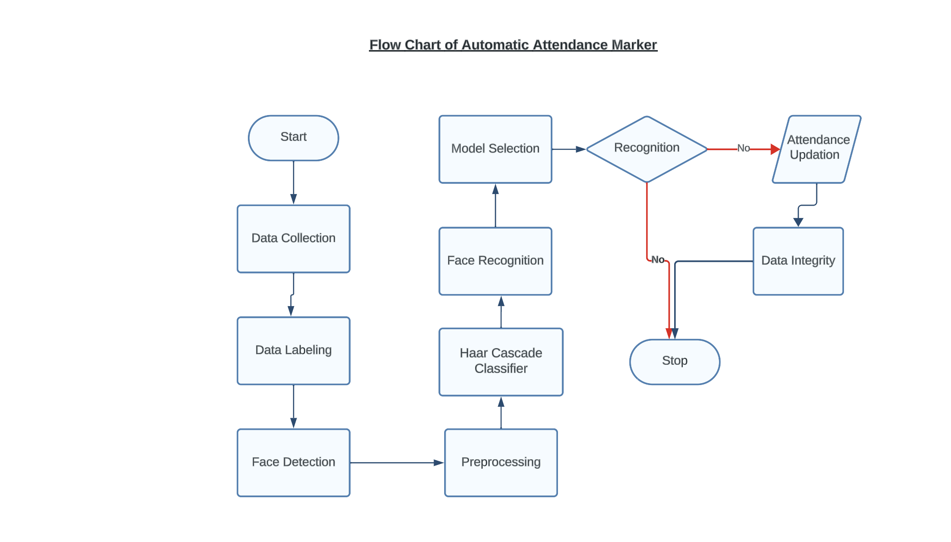

In terms of the system's architecture, it includes these key components and functionalities.

1. **Student’s Dataset Creation:**

Using a webcam, we capture multiple images of a single student. These images then undergo a series of preprocessing steps. First, we crop the images to isolate the Region of Interest (ROI), which will be crucial for the subsequent recognition process. Following this, we resize the cropped images to a specific pixel dimension. These resized images are then transformed from full-color RGB format to grayscale. Finally, we save these images in a dedicated folder, with each image being labeled after the respective student.

1. **Student’s Face Detection:**

We used the machine learning object detection method known as the **Haar Cascade Classifier** to identify faces in the photos. Bounding boxes were drawn around faces in the images that the system discovered and classified based on facial traits. Techniques for post-processing were used to reduce false positives. This involved making sure that only the most certain face detections were taken into account and using non-maximum suppression to get rid of overlapping bounding boxes. 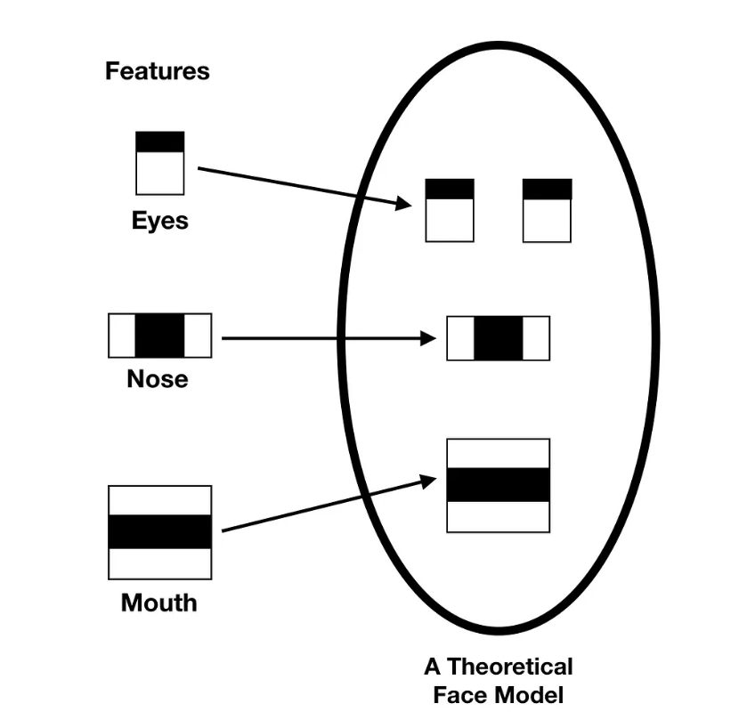

1. **Student’s Face Recognition:**

The process of face recognition entails teaching a model to recognize faces. The actions listed below were carried out: (a) Model Selection: A good face recognition model (such as dlib, OpenCV, or face_recognition) was picked from the Python library of choice. (b) Training the Model: To acquire facial traits and individual unique IDs, the model was trained on the labeled dataset. (c) Recognition and Confidence Threshold: To reduce false positives and false negatives, a recognition algorithm like KNN(K-Nearest Neighbour) was put into place along with a confidence threshold.

1. **Attendance Updation:**

Attendance records were updated in an Excel or CSV file when faces were found and identified. The actions listed below were taken: (a) Marking Attendance: A recognised face was marked as "present" for the particular session if it was determined that the person was registered. (b) CSV/Excel File Handling: All of the attendance data, including name and ID, date, and time, was entered into a structured CSV or Excel file.

1. **Data Integrity and Attendance Marking:**

Data Integrity: Error management and duplicate entry prevention are two steps taken to guarantee data integrity, which helps to display the reliable and accurate result on system application and to maintain Integrity in record .

**Result and Discussion:** This system offers a user-friendly interface with two primary options: student registration, and attendance marking. Students complete a registration form with their details and, upon clicking "Register," the system activates the webcam and opens a window for face detection. It automatically captures photos of students' faces until 50 samples are collected or a specific key combination is pressed, storing these images for further processing in a dedicated folder at run-time.

After student registration , Faculty can take the attendance by clicking “Take attendance”,the system activates the webcam and opens a window for face detection.

It automatically recognises the student face using KNN algorithm and updates the day wise attendance into excel sheet with date and time.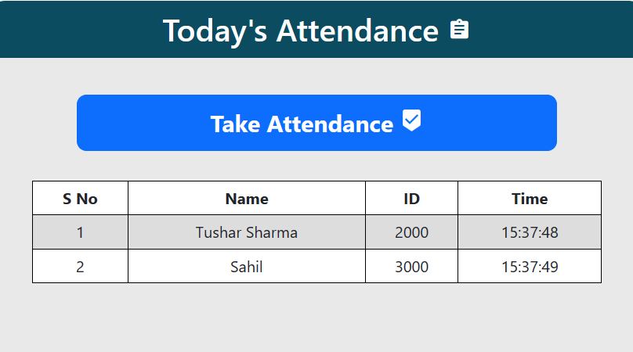

1. **CONCLUSION**

The main goal and objective of this automated attendance system uses face recognition to automatically mark the presence of students or employees in real time. It works in any environment and is very accurate. The system generates attendance reports for easy tracking.

**REFERENCES**

1. R. Mishra, "Persuasive Boundary Point Based Face Detection Using Normalized Edge Detection in Regular Expression Face Morphing," 2023 International Conference on Distributed Computing and Electrical Circuits and Electronics (ICDCECE), Ballar, India, 2023, pp. 1-4, doi: 10.1109/ICDCECE57866.2023.10151015.
2. Y. Zhou, Y. Liang and P. Tan, "Design of an Intelligent Laboratory Facial Recognition System based on Expression Keypoint Extraction," in IEEE Access, doi: 10.1109/ACCESS.2023.3329575.
3. J. Xin, Z. Wei, N. Wang, J. Li and X. Gao, "Large Pose Face Recognition via Facial Representation Learning," in IEEE Transactions on Information Forensics and Security, doi: 10.1109/TIFS.2023.3329686.
4. E. Kakaletsis and N. Nikolaidis, "Active Face Recognition Through View Synthesis," 2023 31st European Signal Processing Conference (EUSIPCO), Helsinki, Finland, 2023, pp. 511-515, doi: 10.23919/EUSIPCO58844.2023.10290036.
5. P. Poonpinij, S. Tarnpradab, N. N. Lumpoon and N. Wattanapongsakorn, "Masked Face Recognition and Identification Using Convolutional Neural Networks," 2023 10th International Conference on Electrical Engineering, Computer Science and Informatics (EECSI), Palembang, Indonesia, 2023, pp. 571-576, doi: 10.1109/EECSI59885.2023.10295922.